# Create a sample of 40 numbers which are normally distributed.

norm <- rnorm(40,0,0.1)

x <- seq(-1,1,length.out = 40)

y <- 2*x+norm

#SLR pass from origin point (0,0) then y = b1*x;

b1<- sum(x*y)/sum(x*x)

# Y origin (Yhat)

y0<- c(b1*x)

c(y0)

[1] -2.01151897 -1.90836415 -1.80520933 -1.70205451 -1.59889969 -1.49574488

[7] -1.39259006 -1.28943524 -1.18628042 -1.08312560 -0.97997078 -0.87681596

[13] -0.77366114 -0.67050632 -0.56735150 -0.46419669 -0.36104187 -0.25788705

[19] -0.15473223 -0.05157741 0.05157741 0.15473223 0.25788705 0.36104187

[25] 0.46419669 0.56735150 0.67050632 0.77366114 0.87681596 0.97997078

[31] 1.08312560 1.18628042 1.28943524 1.39259006 1.49574488 1.59889969

[37] 1.70205451 1.80520933 1.90836415 2.01151897

plot(x,y)

lines(x,y0,col="blue", lwd="2")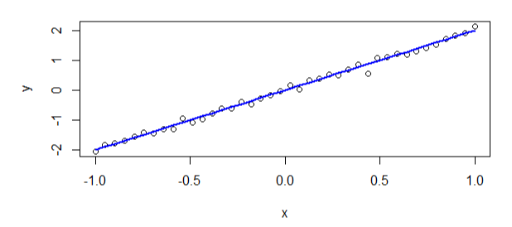

#Error in origin line

e = abs(sum(y-y0))

c(e) = **0.3039365**

# Mean of Yi is Ybar

ybar0 = sum(y)/40

c(ybar0) = **-0.007598413**

#r^2 is SSR/SST

SSR = sum((y0-ybar0)*(y0-ybar0))

c(SSR) = **56.7184**

SST = sum((y-ybar0)*(y-ybar0))

c(SST) = **57.02526**

rsquare <- SSR/SST

c(rsquare) = **0.9946188**

**PART-2 ordinary linear regression yˆi = b0 + b1xi**

#ordinary linear regression yˆi = b0 + b1xi

b1<- sum((x-mean(x))*(y-mean(y)))/sum((x-mean(x))*(x-mean(x)))

c(b1) = **2.011519**

bo <- mean(y)-b1*mean(x)

c(bo)= **-0.007598413**

#bo is very small near to zero '0', so it looks like RTO

yhat = bo+b1*x

c(yhat)

[1] -2.01911738 -1.91596256 -1.81280775 -1.70965293 -1.60649811 -1.50334329

[7] -1.40018847 -1.29703365 -1.19387883 -1.09072401 -0.98756919 -0.88441437

[13] -0.78125956 -0.67810474 -0.57494992 -0.47179510 -0.36864028 -0.26548546

[19] -0.16233064 -0.05917582 0.04397900 0.14713382 0.25028863 0.35344345

[25] 0.45659827 0.55975309 0.66290791 0.76606273 0.86921755 0.97237237

[31] 1.07552719 1.17868201 1.28183682 1.38499164 1.48814646 1.59130128

[37] 1.69445610 1.79761092 1.90076574 2.00392056

plot(x,y)

lines(x,yhat,col ="red",lwd ="2")

abline(h=0,v=0)

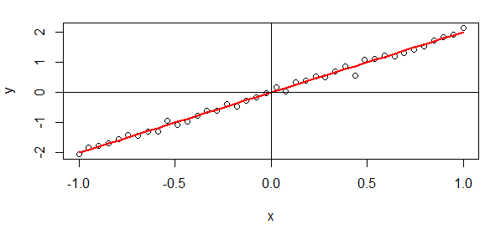

#calculate error e1

# error almost zero.

e1<-abs(sum(y-yhat))

c(e1) = **1.491862e-15**

#calculate r^2 = SSR/SST

# SSR

SSR1 <- sum((yhat -mean(y))*(yhat -mean(y)))

c(SSR1) = **56.71609**

# SST

SST1 <- sum ((y-mean(y))*(y -mean(y)))

c(SST1) = **57.02526**

#rsquare shows the prefect correlation.

rsquare1 <-SSR1/SST1 c(rsquare1) = **0.9945783**